AFROTC Detachment 842

Fall 2024

Commissioning Ceremony



The University of Texas at San Antonio

13 Dec 2024

**Sequence of Events**

Arrival of Official Party

National Anthem

Invocation

Guest Speaker

Commissioning Ceremony

Closing Remarks

Air Force Song

**Detachment 842 Cadre**

Col Gregory Cyrus

Mr. Agustin Llano

Maj Tina-Rose Cavazos

Maj Landon Prendergast

Capt Steffon Jackson

Capt Jennifer Hurt

TSgt Erren Barnes

TSgt(S) Rashaad Taylor

SSgt Rachel Mangru

SSgt Paige Archer

Mr. Greg Gaines

Detachment 842 Commander

AFROTC Program Manager

Director of Operations

Operations Flight Commander

Recruiting Officer

Education Officer

Senior Enlisted Leader

NCOIC, Cadet Actions

AFROTC Instructor

NCOIC, Administration

Physical Training Officer

**COLONEL PATRICIA A. GRIFFIN (RET)**

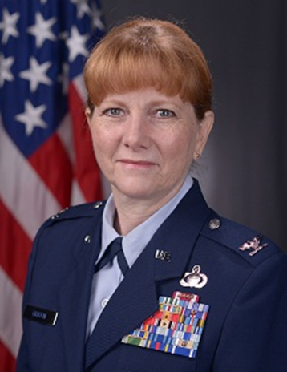

Colonel Patricia Griffin retired as the IMA to the Director of Intelligence, Operations & Nuclear Integration for the Air Education & Training Command (AETC) at Joint Base San Antonio-Randolph, Texas. In this capacity, she supported the Director in his responsibilities for training all Air Force career fields and advised on all IMA Reserve activities.

Colonel Griffin was commissioned in 1986 at USAF Officer Training School, Lackland AFB, TX. Her initial active duty assignment was as the OIC of Intelligence for one of the four F-111F Fighter Squadrons at RAF Lakenheath, UK. Col Griffin initially entered the USAF Reserve IMA program and performed duty as a Command Briefer at NORAD. She then went to Maxwell AFB, AL and was a member of the Secretary of the Air Force Gulf War Illness Declassification Team as well as part of the Opposing Forces Intelligence CADRE at the Wargaming Institute. After that, Col Griffin moved to Naples, Italy where she directly supported COMAIRSOUTH during Operation ALLIED FORCE. From Naples she moved to Spangdahlem, Germany where she was triple-hatted as the Acting Chief of Advanced Programs, the Intelligence Flight Commander and the Chief, Intelligence IG Evaluator for the 52d Fighter Wing. From Germany, she moved to Randolph AFB, TX where she was the Chief of Intelligence Operations for HQ AETC. Col Griffin attended the National Intelligence University at Bolling AFB, DC and while there she completed Air Command and Staff College and Air War College. Col Griffin moved back to Lackland AFB, TX as the HAF HUMINT Liaison to AF ISR Agency. She was then selected to be the Deputy Director of Applications and Analysis (A2). She subsequently was selected to be the Deputy Director of Operations for the 318th Information Operations Group (IOG), 688th Information Operations Wing, 24 Air Force, Lackland AFB, TX. Her next move was to HQ AETC, Randolph AFB, TX as the AETC Deputy Director of Staff. Her most recent assignment was to the USPACOM JIOC as the Joint Detachment Air Force Element Director at Minneapolis, MN. During her tenure at USPACOM she also performed duty as the 17 TRG Deputy Commander at Goodfellow AFB, TX. Additionally, Col Griffin was selected to be the J2 at Deagu, South Korea during Exercise ULCHI FREEDOM GUARDIAN 2012. Col Griffin’s follow-on assignment was as the IMA to the Director of Operations at the Air Force Intelligence, Surveillance and Reconnaissance Center at Joint Base San Antonio-Lackland, Texas. During this time she also served as the Chief of Intelligence for the Joint Information Operations Warfare Center. Col Griffin has deployed twice; once in 2000-2001 in support of Operation SOUTHERN WATCH as the Intelligence Flight Commander at Al Jaber, Kuwait and then later in 2008 in support of Operation IRAQI FREEDOM as the Chief, Special Programs for TASK FORCE Troy and the ISR Liaison to the Air Component Coordination Element – Iraq Director at Camp Victory, Baghdad, Iraq. Col Griffin attended Advanced Joint Professional Military Education (JPME II equivalent) and has a Bachelors’ Degree in Management from the University of Maryland, a Masters’ Degree in Human Resources Management from Chapman University and a Masters’ Degree in Strategic Intelligence from National Intelligence University.

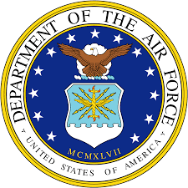

**Fall 2024 Commissioning Class**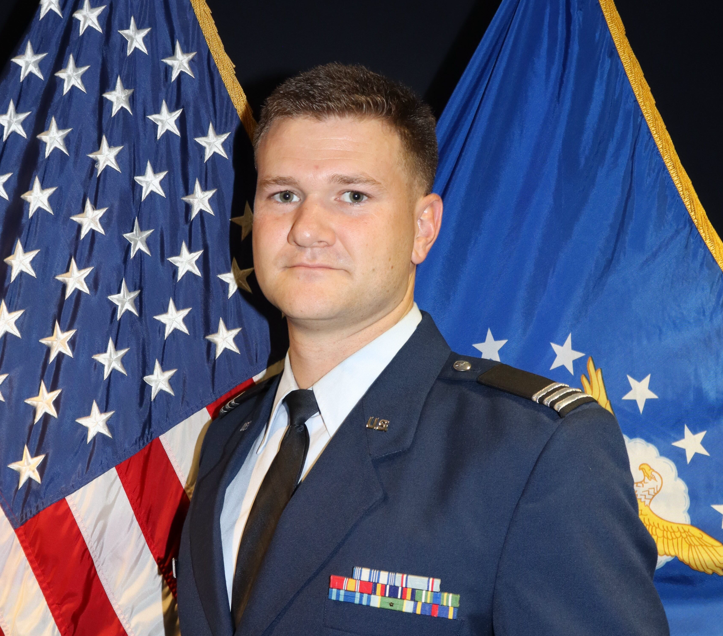

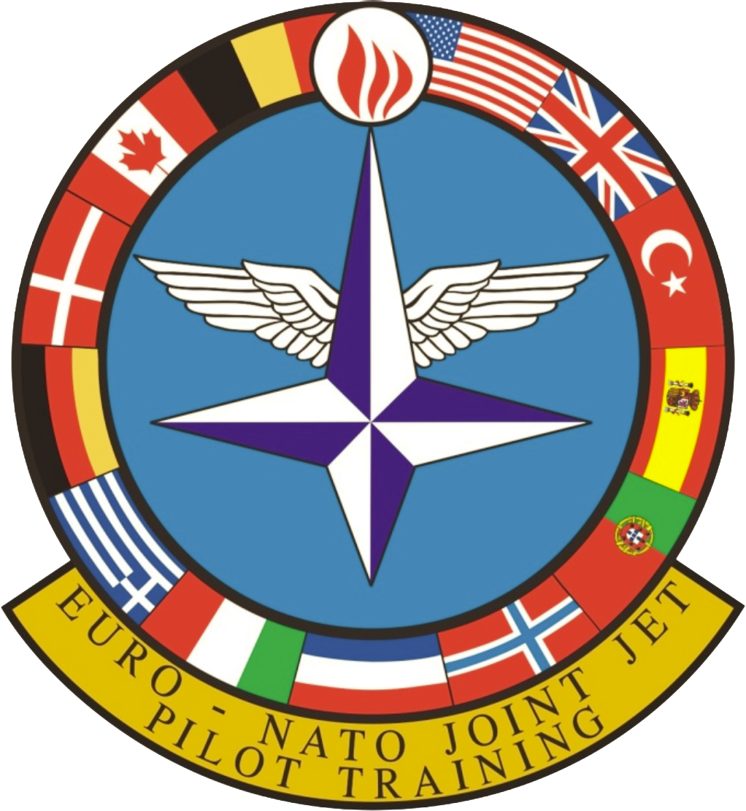

**Second Lieutenant Connor Griffin**

Second Lieutenant Connor Griffin graduated Magna Cum Laude from the University of Texas at San Antonio with a Bachelor of Arts in Multidisciplinary Studies with a concentration in Aerospace Studies, Business, and History. Lieutenant Griffin will commission as an Aircraft Pilot, heading to Sheppard AFB, Texas to begin Undergraduate Pilot Training (UPT).

Lieutenant Griffin last held the position of Inspector General at Detachment 842, University of Texas at San Antonio. In this capacity, his primary role was ensuring that good order and discipline were consistently upheld within the detachment. This involved maintaining a structured and respectful environment where all cadets understand and adhere to established rules and standards. Additionally, he was responsible for the health and well-being of all cadets, ensuring they had the necessary support and resources to thrive mentally and physically. Lieutenant Griffin entered the Air Force in August 2017 through a 6-year active duty enlistment. He completed Tactical Aircraft Maintenance training in March of 2018 and has held various Mechanic and Leadership positions since then. He has been stationed at Holloman AFB, NM, Osan AB, ROK, Eielson AFB, AK, and lastly at Lackland AFB, TX for his transition to the Reserves via Palace Chase.

**Commissioned by:** Lt Col Edward Griffin, USAF (Ret)

**Pinned by:** Rowan, Zane, and Deanna Griffin

**First Salute:** TSgt Deanna Griffin, USAF

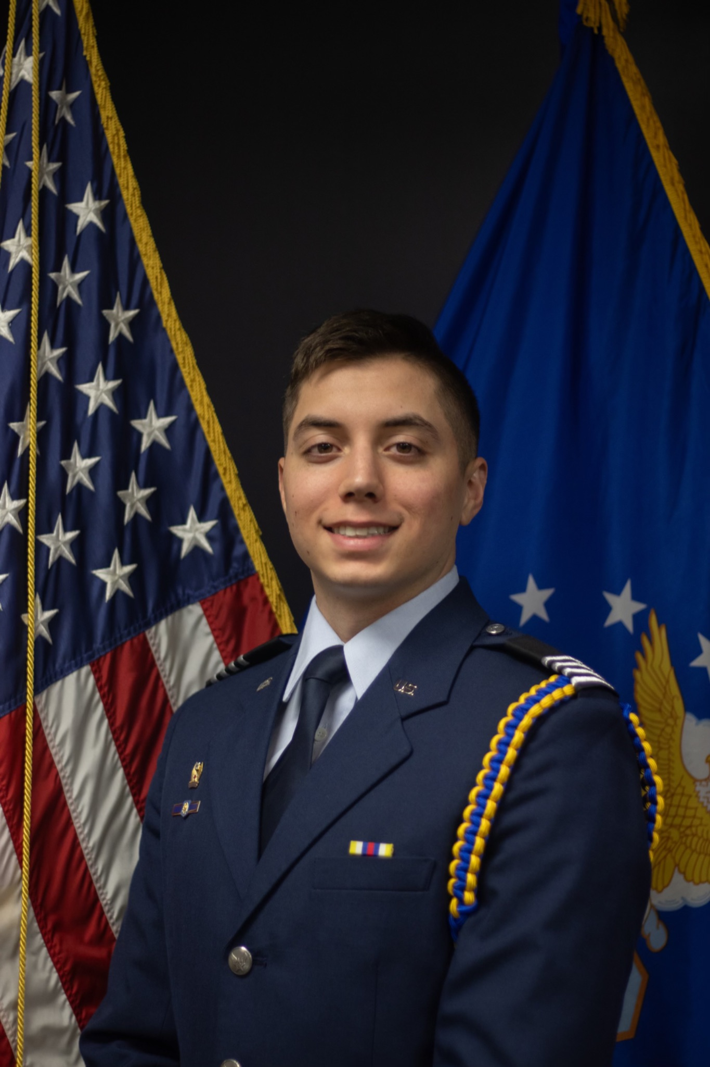

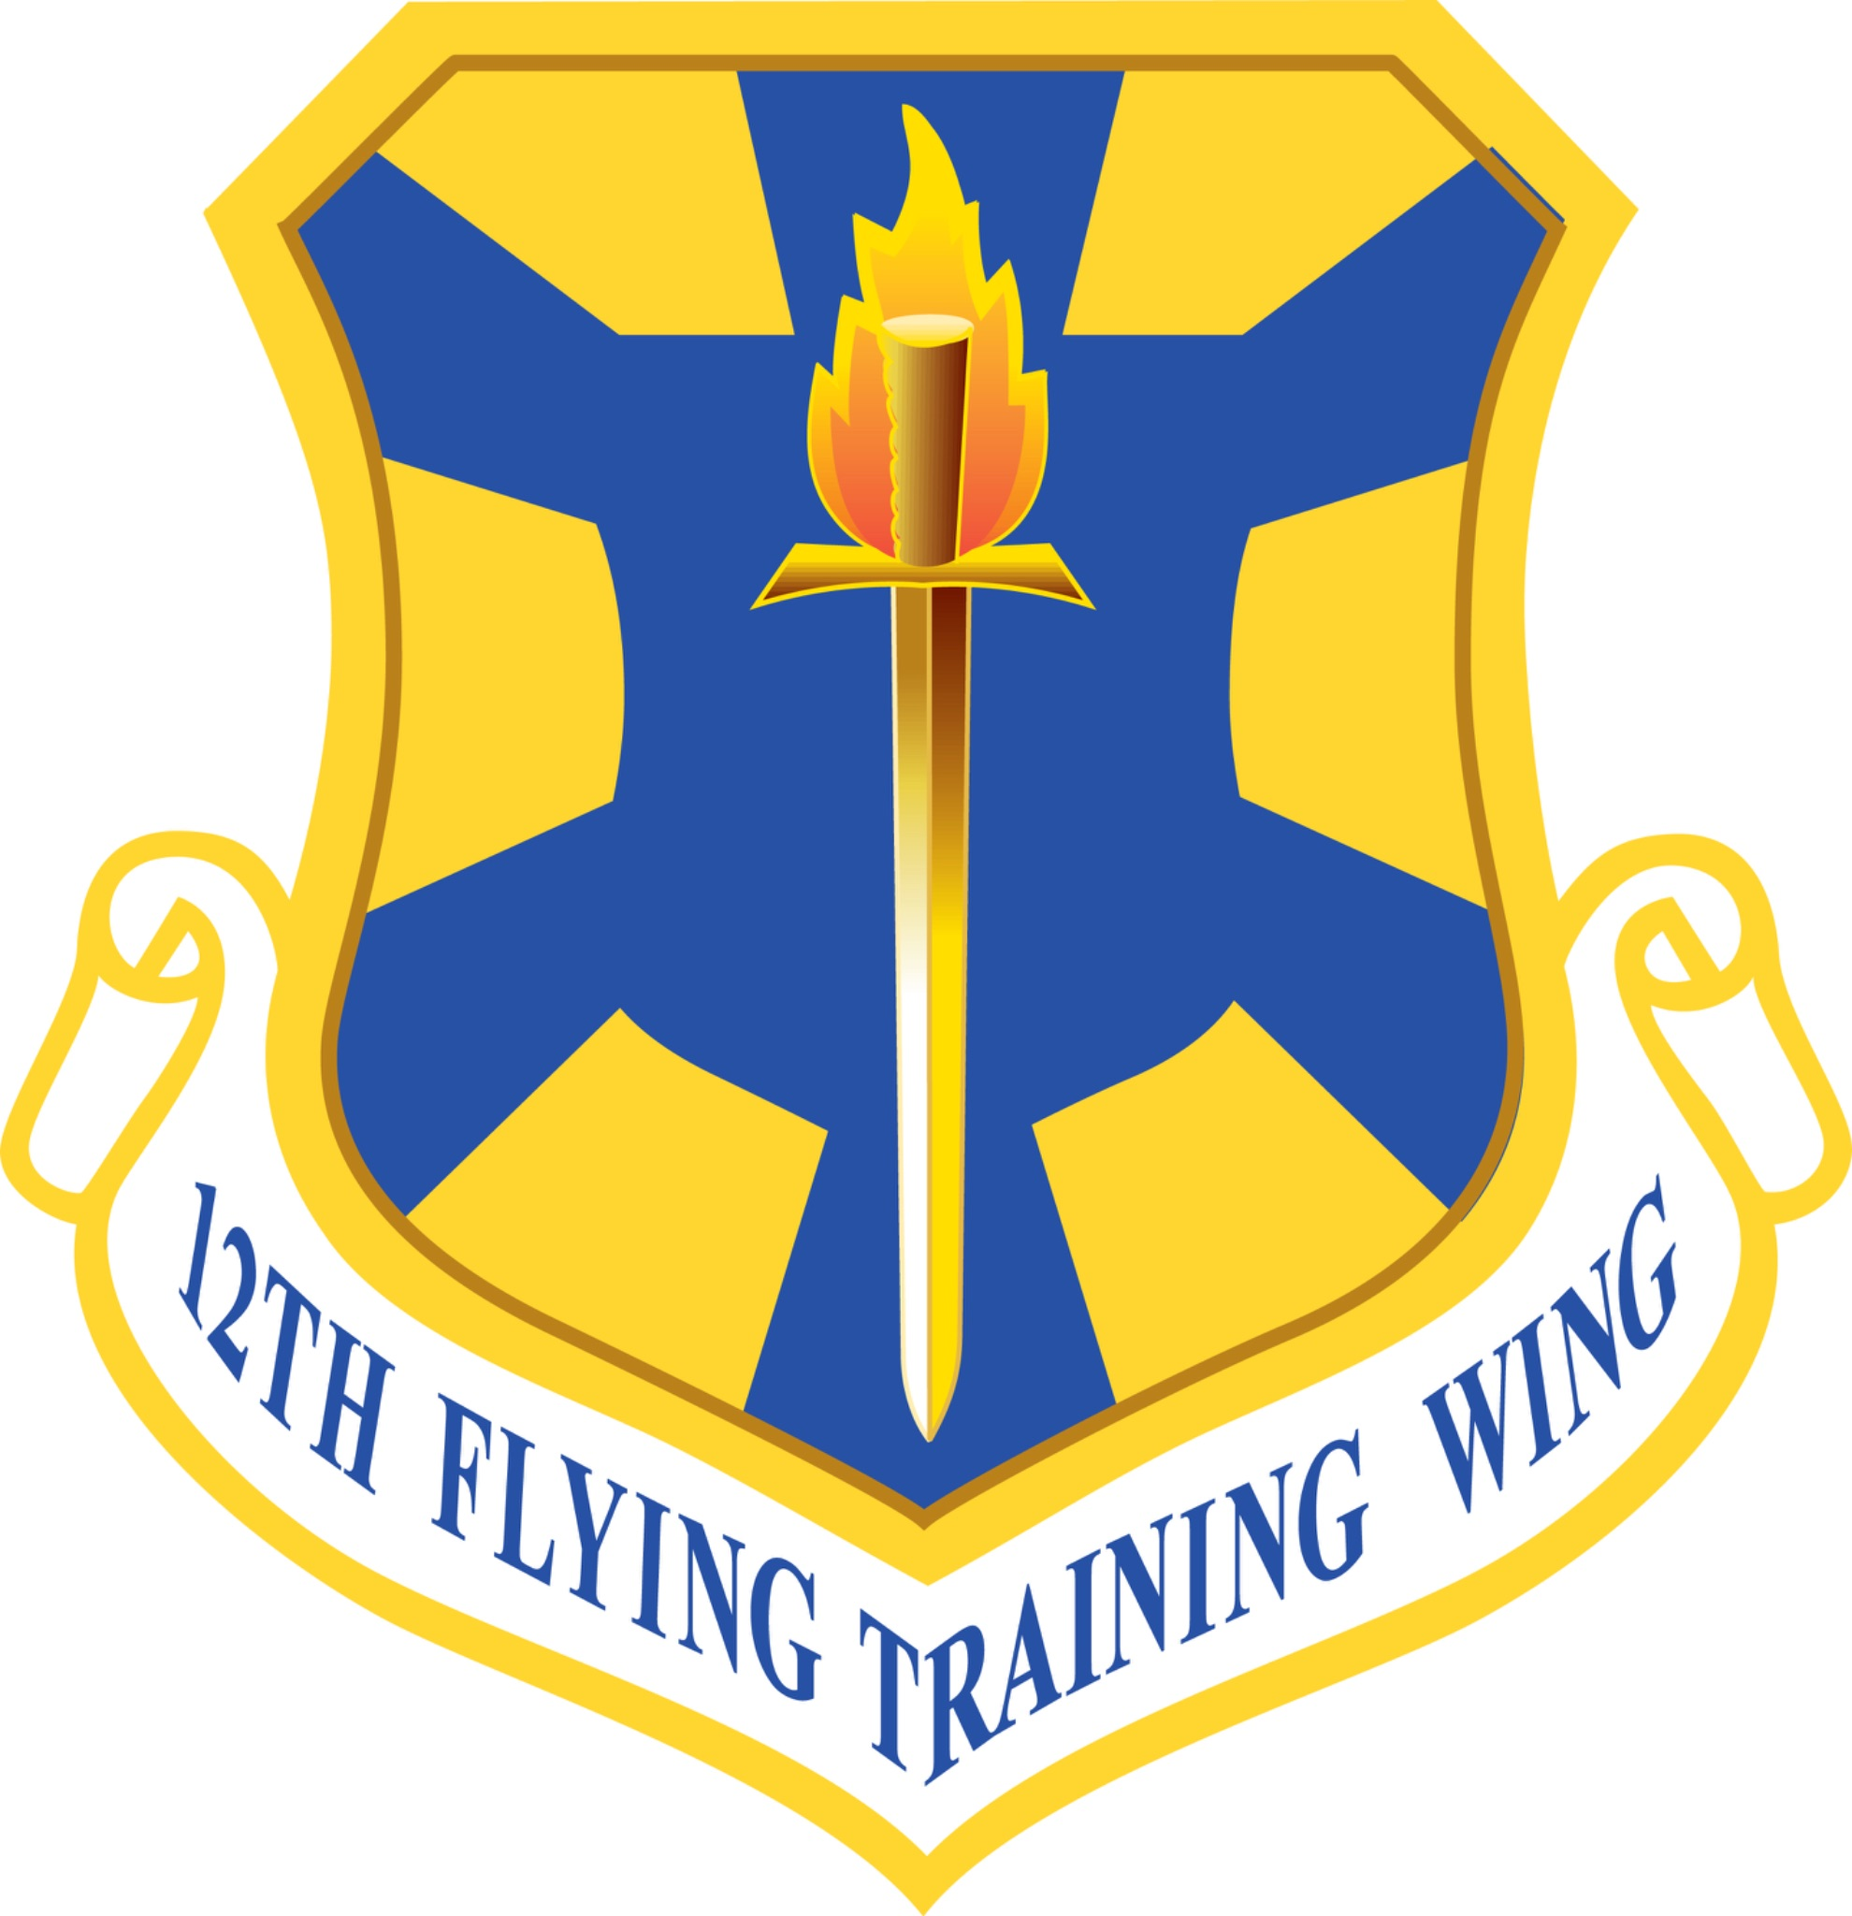

**Second Lieutenant Joseph Rosner**

Second Lieutenant Joseph Rosner graduated from the University of Texas at San Antonio with a Bachelors of Science Degree in Computer Science with a concentration in Software Engineering. Lieutenant Rosner will commission as a Remotely Piloted Aircraft Pilot at Randolph AFB, Texas.

During his time as a cadet at Detachment 842, Lieutenant Rosner was an avid member of Arnold Air Society, an honorary service organization focused on giving back to the community and developing exceptional Air Force officers. Arnold Air Society gave him the opportunities to travel to National Conclaves and learn from senior military and government officials aiding to the development of becoming an Air Force officer. During the summer of 2023, he was given the opportunity to travel to the Air Force Academy learning from Military Training Instructors to develop and train incoming Prep School Candidates. Lieutenant Rosner has held multiple upper leadership positions such as Operations Group Commander, and Vice Wing Commander, both contributing to the development and overall mission of the detachment. Lieutenant Rosner would like to contribute his past, current, and future success to his family, friends, and mentors who helped develop him into the Air Force officer and person he is today.

**Commissioned by:** 2d Lt Jeremiah Ramirez, USAF

**Pinned by:** Michelle, Phillip, Stephanie, Danielle, and Erin Rosner

**First Salute:** Hospital Corpsman 1st Class Louis Calcagni, USN (Ret)

**Oath of Office**

I, (state your name),

having been appointed a Second Lieutenant

in the United States Air Force,

do solemnly swear (or affirm)

that I will support and defend the Constitution of the United

States against all enemies, foreign and domestic;

that I will bear true faith and allegiance to the same;

that I take this obligation freely,

without any mental reservation or purpose of evasion;

and that I will well and faithfully discharge the duties

of the office upon which I am about to enter.

So help me God. 

**Air Force Song**

Off we go into the wild blue yonder,

Climbing high into the sun;

Here they come zooming to meet our thunder,

At ‘em now, give‘em the gun!

Down we dive, spouting our flame from under,

Off with one helluva roar;

We live in fame or go down in flame.

Hey!

Nothing’ll stop the U.S. Air Force!

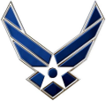

***Thank you to everyone***

***who helped make***

***this day possible!***

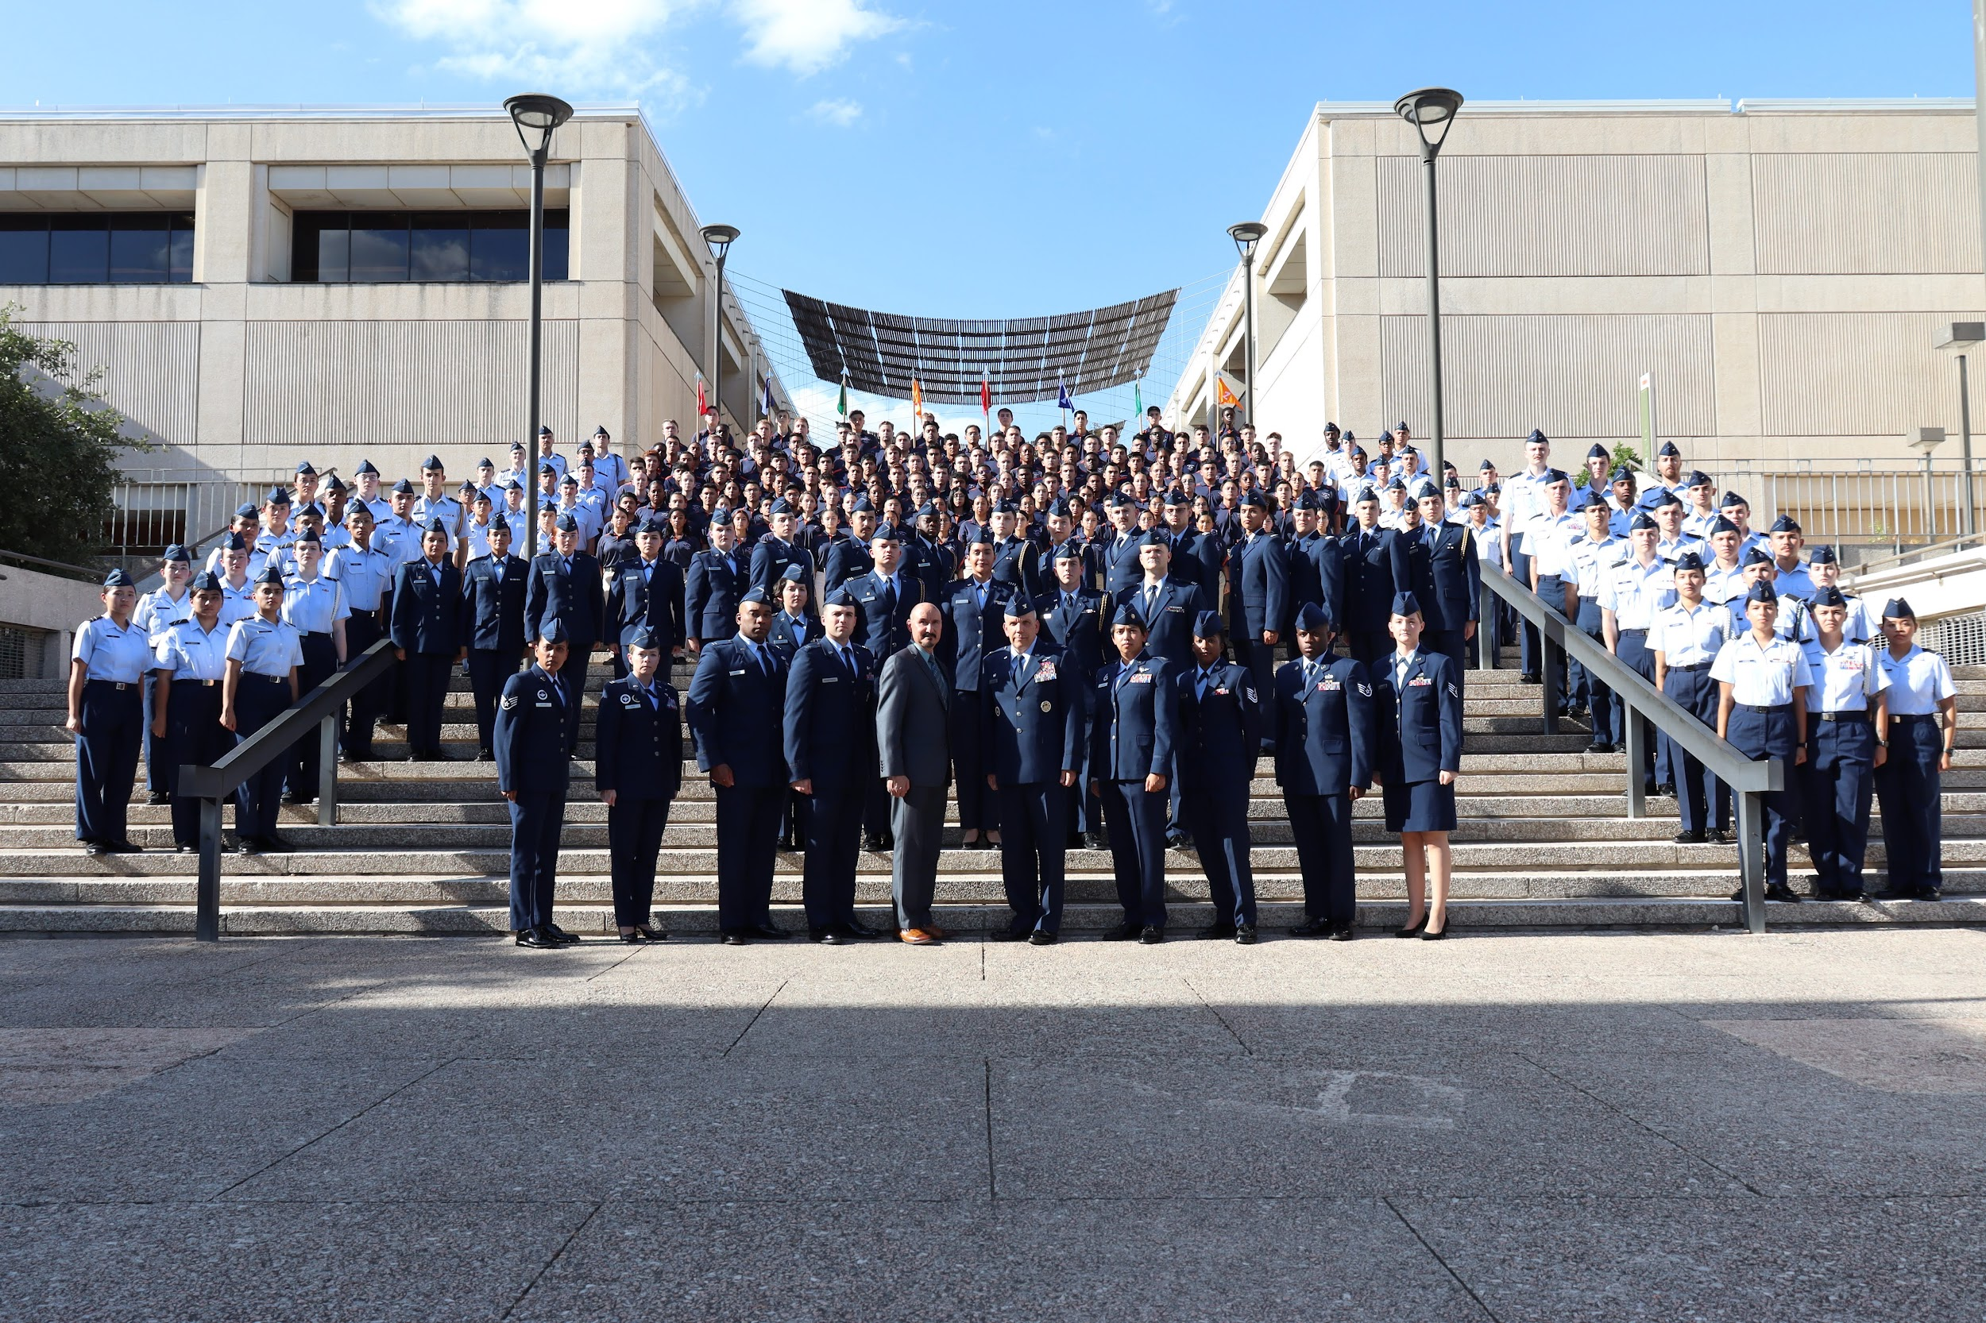

***“Det 842…Best in Blue!”***

*842…Best in Blue!”*